

**LAB MANUAL OF**

**ARTIFICIAL INTELLIGENCE**

**Name :**

**ZULFIQAR ALI**

**DEPARTMENT:**

**Information Technology**

**Roll No :**

**BIT-24S-005**

**COURSE:**

**Artificial Intelligence**

**SUBMITTED TO:**

**AQSA UMAR**

**DATE:**

**11-04-2025**

**TABLE OF CONTEXT**

|  |  |
| --- | --- |
| **LAB** | **TASK** |
| **01** | **PYTHON DATA TYPES** |
| **02** | **PYTHON LOOPS** |
| **03** |  |
| **04** | **ARITHMETIC OPERATORS** |
| **05** | **IF AND ELSE STATMENT** |
| **06** | **FOR AND WHILE LOOPS** |

**(LAB TASKS)**

**LAB #01**

Q. MAKE 2 -2 PROGRAMS OF EACH DATA TYPE

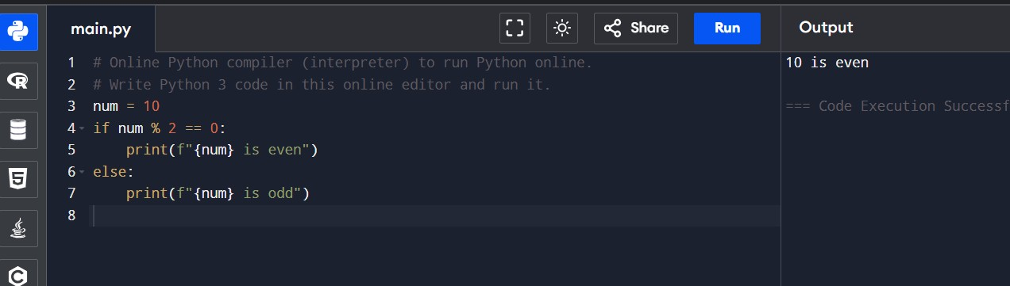

# MAKE UP TO 5 SHAPE PROGRAMS USING

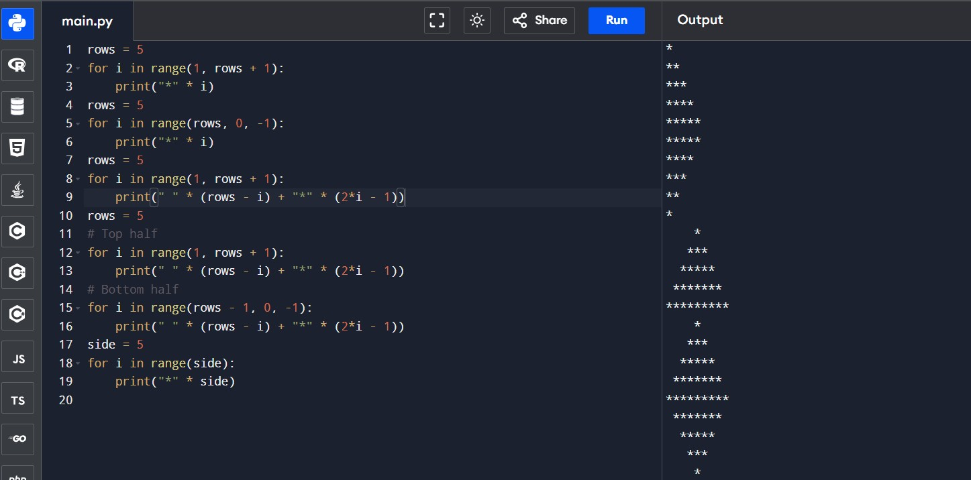

#MAKE SAME SHAPES YOU HAVE MADE IN TASK 2 USING * MULTIPLE BY NUMBER

**LAB # 2**

#Print numbers from 1 to 10 using a for loop.

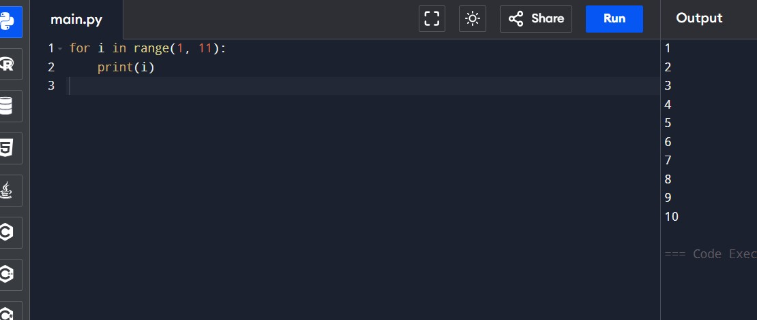

#Print all even numbers between 1 and 20 using a while loop.

#Calculate the sum of numbers from 1 to 100 using a loop.

#Print the multiplication table of 5 using a loop.

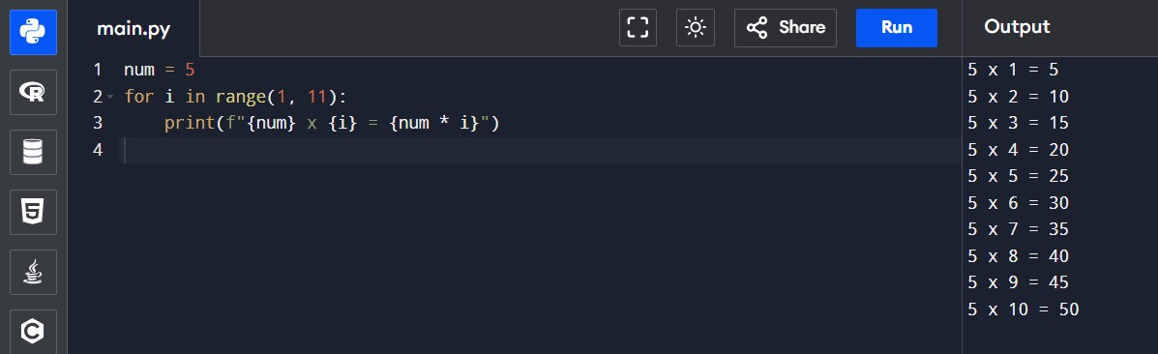

#Find the factorial of a given number using a for loop.

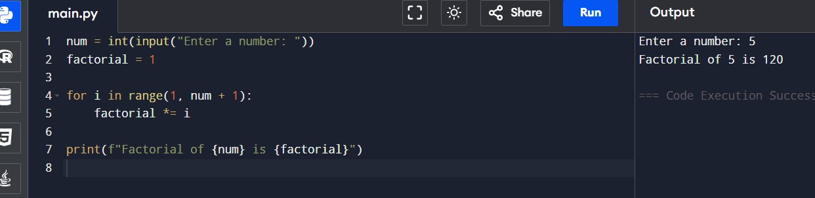

#Iterate over a list of fruits and print each item.

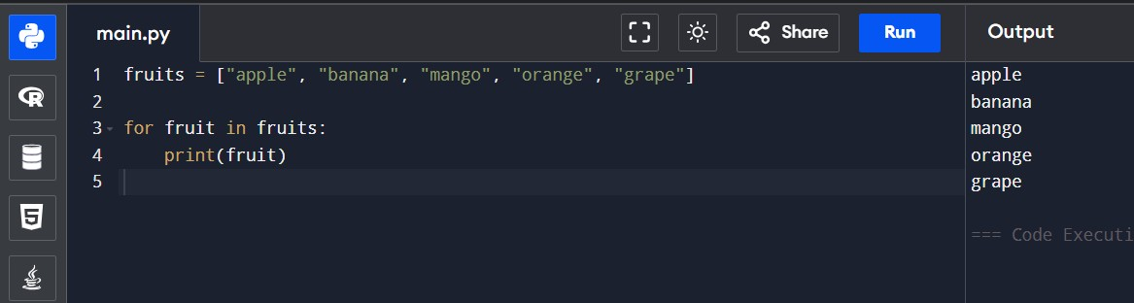

#Create a list of numbers and print only the odd numbers using a loop.

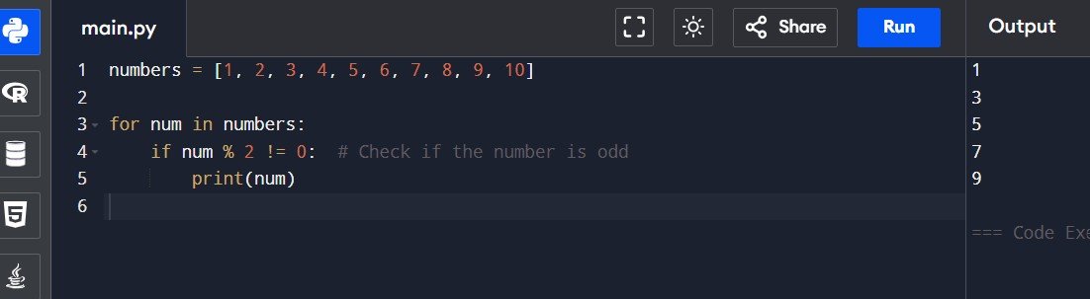

**LAB 04:**

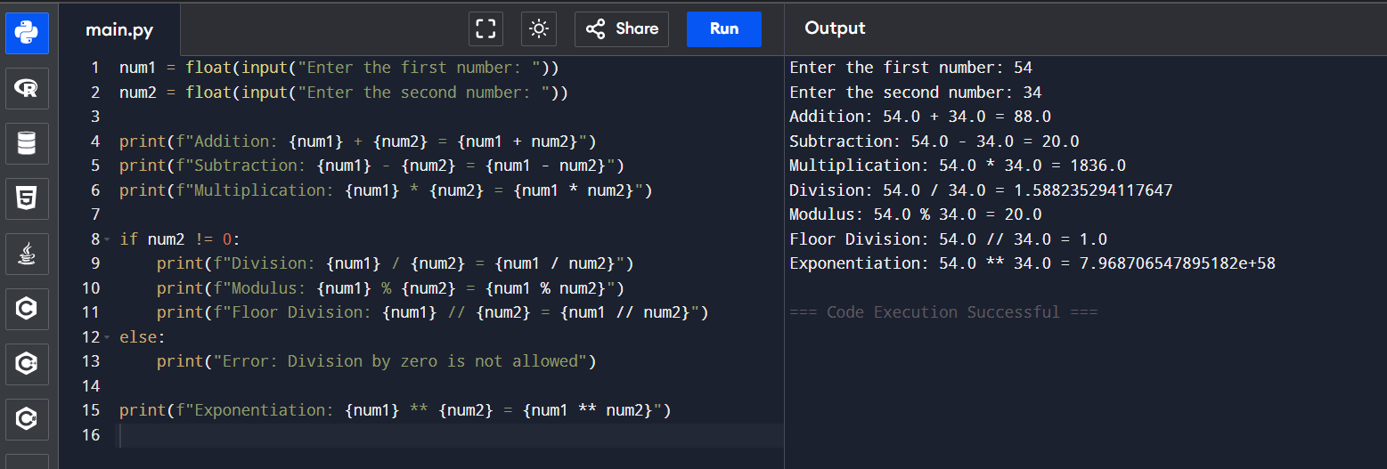# Write a python program to take two numbers as input and perform all arithmetic operators on them.

# Create a function that takes two numbers & returns their sum-sub-product-division.

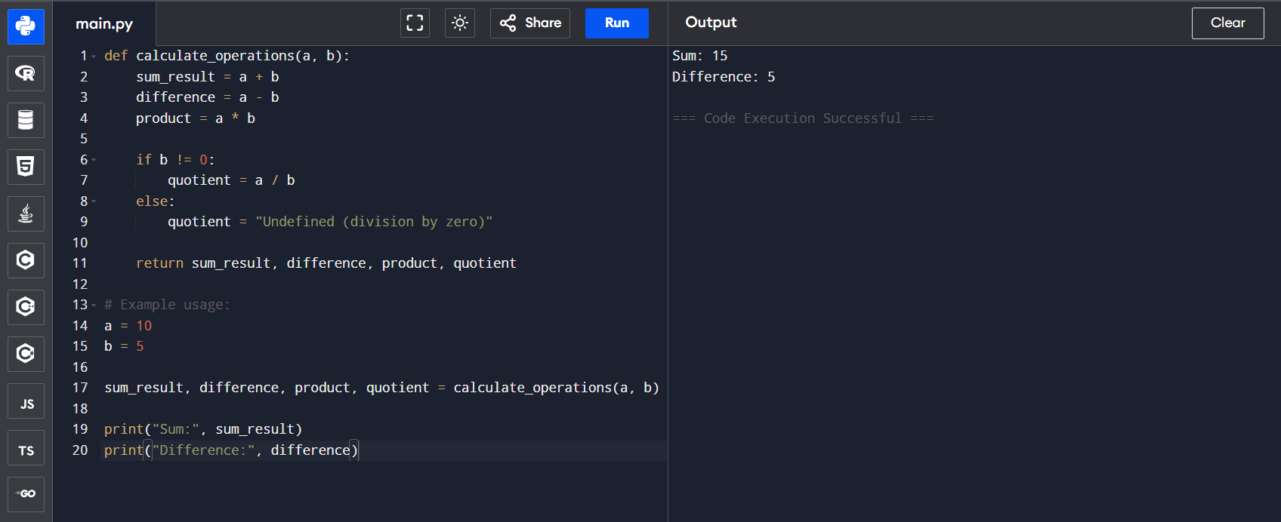

# Write a python script to find the remainder when one number is divided by another.

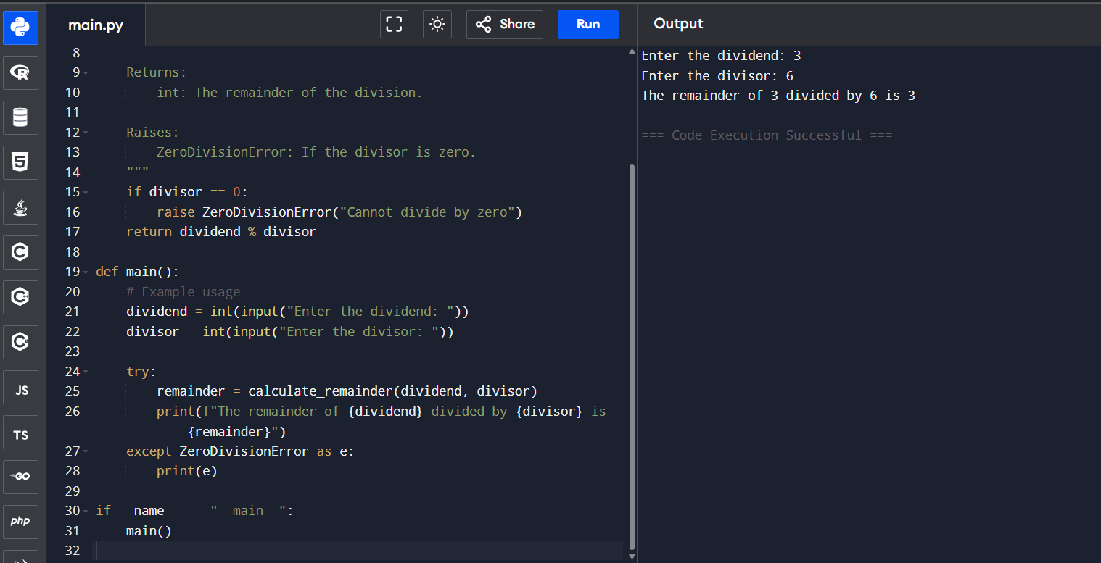

# Write a program to calculate the area of circle using the formula

(Area =π*r^2).

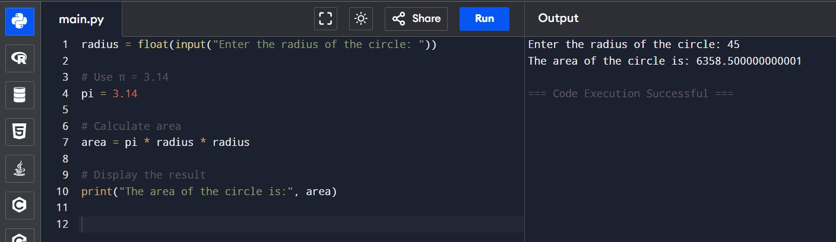

#Implement a program that takes a number as input & returns its square & cube using exponential.

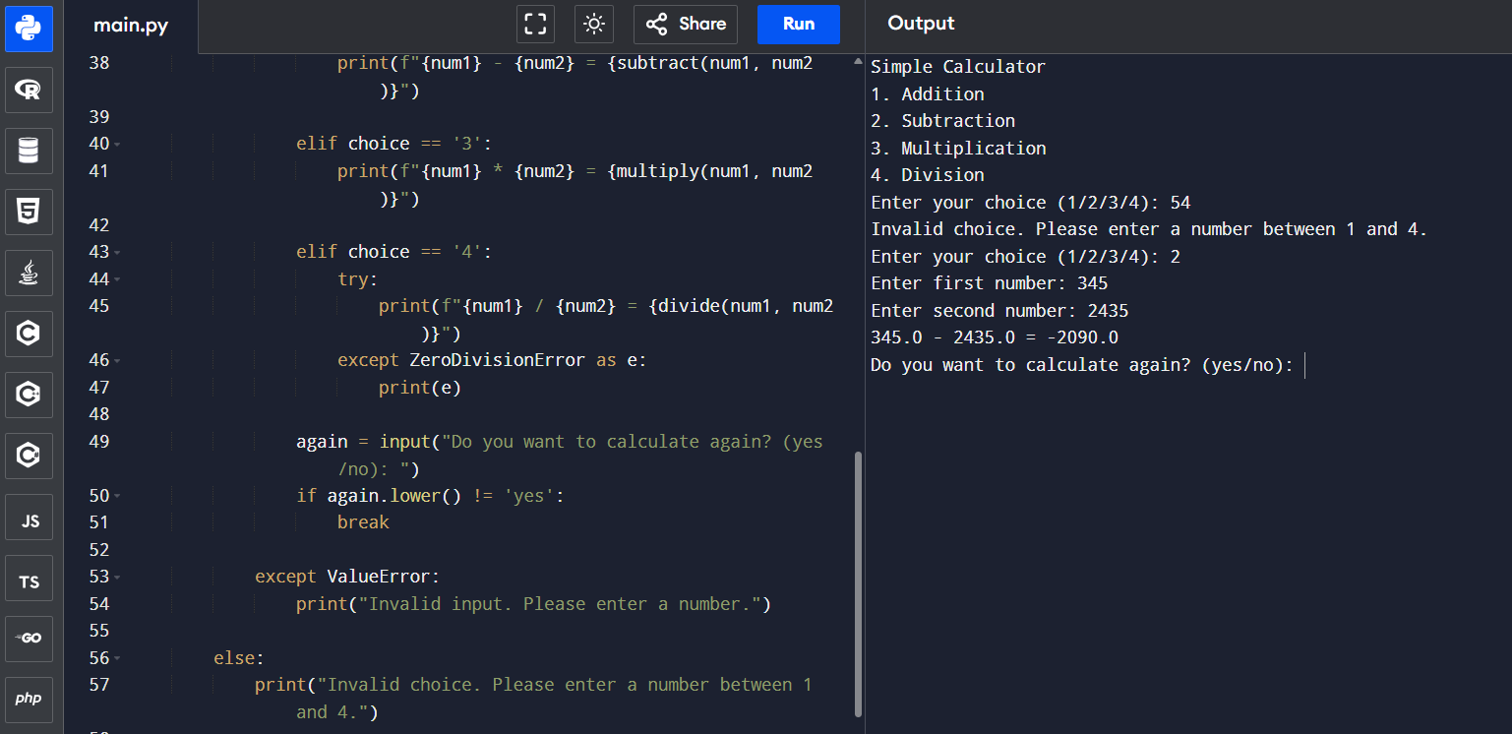

# Create a simple calculator in python that allows the user to choose an operation (addition, subtraction,etc) & inputs two numbers.

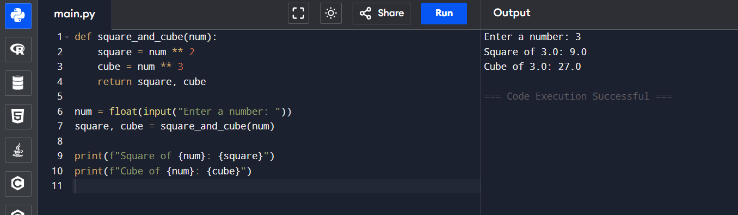

**LAB 05**

# Write a program that checks if a given number is positive, negative or zero.

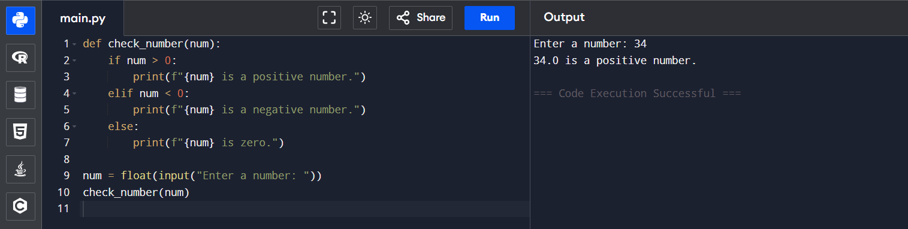

# Write a program that takes user input & determines whether it’s an even or odd.

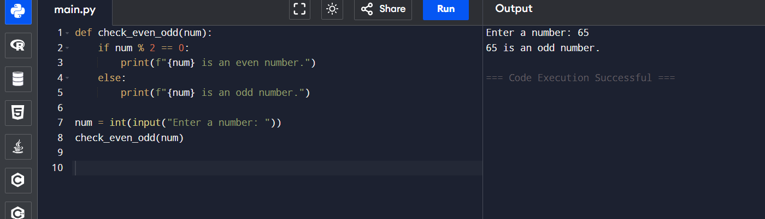

# Create a program that takes asks user to print

“excellent” if marks are above 80

“good” if marks are between 60 to 80

“needs improvement” if marks are below 60.

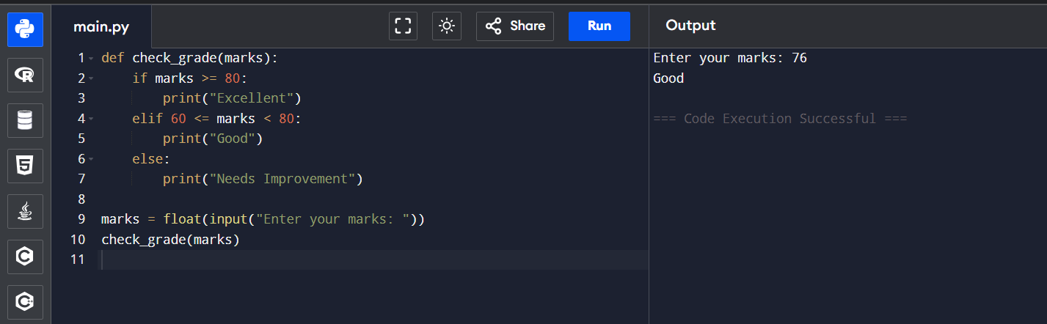

**LAB 06**

# Write a for loop to print the first 10 natural numbers.

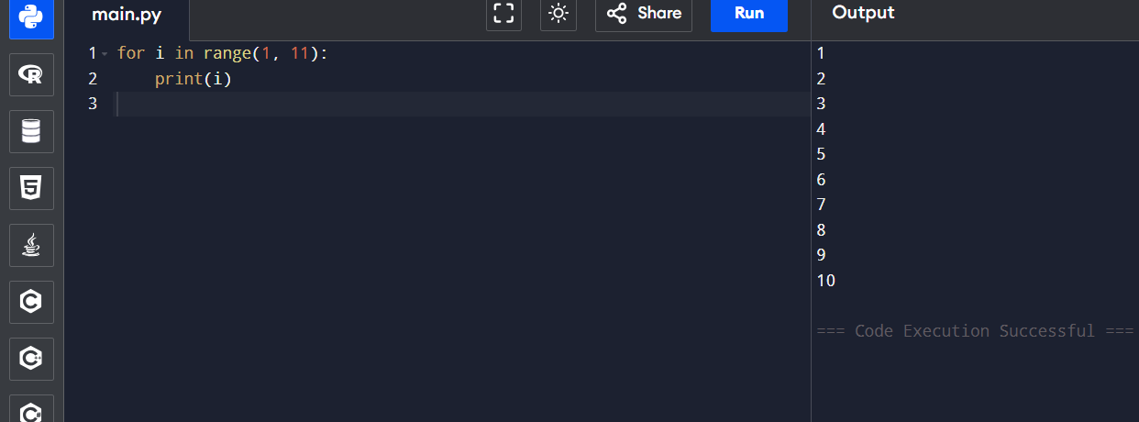

# Write a while loop that prints numbers from 10 down to 1.

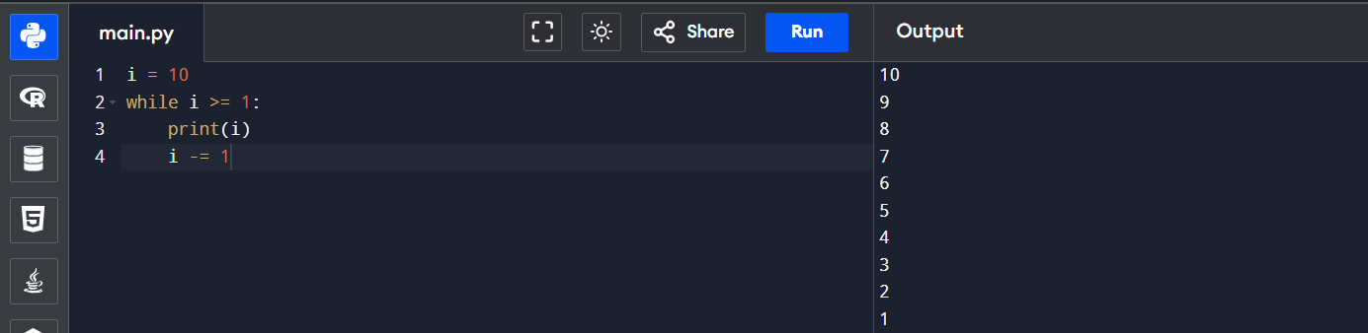

# Create a program that uses a for loop to iterate over a string & count the number of a vowels.

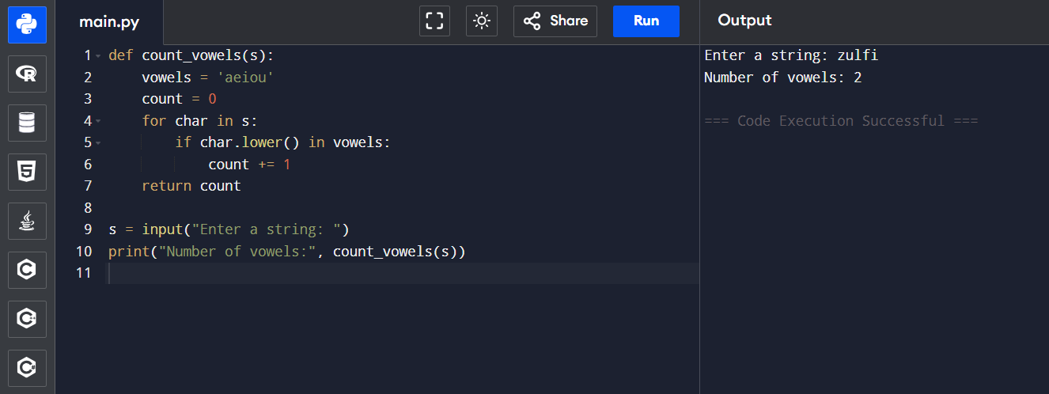

# Write a program that prints the Fibonacci series up to n terms using a while loop.

